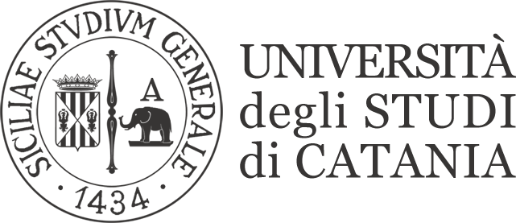
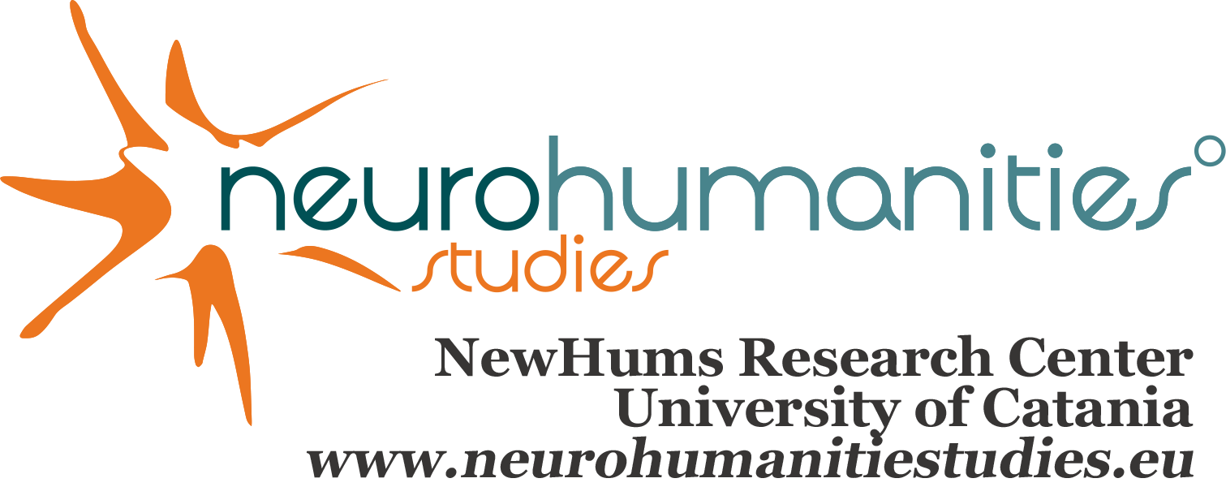

NewHums Research Centre – Neurocognitive and Humanities Studies
International NeuroHumanities Studies Network
University of Catania

6th NHS Dialogue 2019
Beauty and Embodiment in the Arts

24-25 May 2019
Catania, Benedictine Monastry, Machiavelli Theatre

24th May
Coro di Notte, Benedictine Monastery

9.30-9.45
Opening and welcome
Rector Magnificus
Head of the Department DISUM

9.45 - 10.15
Renata Gambino, Grazia Pulvirenti
Tracing embodiment in the Eighteenth Century

Chair: …

10.15 - 10.45
Amy Cook
Cognitive contagion: thinking with and through theatre

10.45 - 11.00
Discussion

11.00 - 11.30
Coffee Break

11.30 - 12.00
Alexander Bergs
Language and Embodiment

12.00 - 12.30
Sara Uboldi
Metamorphosis, Deixis and Embodiment. A case study: Lampedusa’s final masterpiece Lighea

12.30 - 13.00
Discussion

13.00-15.00
Lunch

Chair: Daniela Giordano

15.00 - 15.45
Vittorio Gallese
Embodied Simulation and its Role in Aesthetic Experience

15.45 - 16.15
Discussion

16.15 - 16.45
Fausto Caruana
The Double Life of Facial Expressions, from emotional displays to communicative gestures

16.45 - 17.15
Coffee Break

17.15 - 17.45
Stefano Ballerio
"Passion”: Embodiment, Interpretation, and the Language of Emotions

17.45 - 18.15
Pierre Louis Patoine
Joycean Text / Empathic Reader: A Modest Contribution to Literary Neuroaesthetics
18.15 - 19.00
Discussion

20.30
Social Dinner

25th May
Coro di Notte, Benedictine Monastery

Chair: …

9.30 - 10.15
Monika Fludernik
The Sublime as Embodied Aesthetic

10.15 - 10.45
Discussion

10.45 - 11.15
Jan Söffner
The Bodily Meaning of Narrative. Why language processing is such a hard task for AI

11.15 - 11.45
Coffee Break

11.45 - 12.15
Pascal Nicklas & Emine Gurbutz
Emotional Contagion in Reading Fiction: Insights from Psychological Responses

12.15 - 12.45
Discussion

Lunch

Machiavelli Theatre

Chair: …

15.00 - 15.30
Benito Elìas Garcìa
Some Challenges of embodying Japanese Aesthetics

15.30 - 16.00
Semir Zeki
Beauty in the Brain

16.00 - 17.30
Final Roundtable

